The Royal George Cottingham

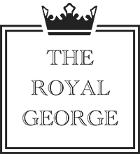

Petiscos Portuguese Bar snacks
Chicken gizzards 5.00
Salt Cod fish cakes 5.00
meat balls " albondigas" 5.00 (tomato and garlic)

Pizzas
4 Seasons, mushrooms, peppers, chorizo, onions
Marguerita
Vegetarian, Goats cheese red onions
Pepperoni 15.00

